**Keyboard & Mouse Event using Action Class in Selenium Webdriver**

In this tutorial, we will learn handling Keyboard and Mouse Event in Selenium Webdriver

**Handling Keyboard & Mouse Events**

Handling special keyboard and mouse events are done using the **Advanced User Interactions API**. It contains the **Actions** and the **Action** classes that are needed when executing these events. The following are the most commonly used keyboard and mouse events provided by the Actions class.

|  |  |
| --- | --- |
| **Method** | **Description** |
| **clickAndHold()** | Clicks (without releasing) at the current mouse location. |
| **contextClick()** | Performs a context-click at the current mouse location. |
| **doubleClick()** | Performs a double-click at the current mouse location. |
| **dragAndDrop(source, target)** | Performs click-and-hold at the location of the source element, moves to the location of the target element, then releases the mouse.  **Parameters:**  source- element to emulate button down at.  target- element to move to and release the mouse at. |
| **dragAndDropBy(source, x-offset, y-offset)** | Performs click-and-hold at the location of the source element, moves by a given offset, then releases the mouse.  **Parameters**:  source- element to emulate button down at.  xOffset- horizontal move offset.  yOffset- vertical move offset. |
| **keyDown(modifier_key)** | Performs a modifier key press. Does not release the modifier key - subsequent interactions may assume it's kept pressed.  **Parameters**:  modifier_key - any of the modifier keys (Keys.ALT, Keys.SHIFT, or Keys.CONTROL) |
| **keyUp(modifier _key)** | Performs a key release.  **Parameters**:  modifier_key - any of the modifier keys (Keys.ALT, Keys.SHIFT, or Keys.CONTROL) |
| **moveByOffset(x-offset, y-offset)** | Moves the mouse from its current position (or 0,0) by the given offset.  **Parameters**:  x-offset- horizontal offset. A negative value means moving the mouse left.  y-offset- vertical offset. A negative value means moving the mouse up. |
| **moveToElement(toElement)** | Moves the mouse to the middle of the element.   **Parameters**:  toElement- element to move to. |
| **release()** | Releases the depressed left mouse button at the current mouse location |
| **sendKeys(onElement, charsequence)** | Sends a series of keystrokes onto the element.   **Parameters**:  onElement - element that will receive the keystrokes, usually a text field  charsequence - any string value representing the sequence of keystrokes to be sent |

In the following example, we shall use the moveToElement() method to mouse-over on one Mercury Tours' table rows. See the example below.

[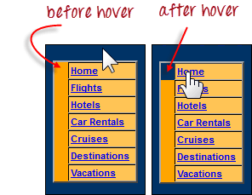](http://cdn.guru99.com/images/image046.png)

The cell shown above is a portion of a <TR> element. If not hovered, its color is #FFC455 (orange). After hovering, the cell's color becomes transparent. It becomes the same color as the blue background of the whole orange table.

**Step 1:**Import the **Actions** and **Action** classes.

[Keyboard & Mouse Event using Action Class in Selenium Webdriver](http://cdn.guru99.com/images/image047.png)

**Step 2:**Instantiate a new Actions object.

[Keyboard & Mouse Event using Action Class in Selenium Webdriver](http://cdn.guru99.com/images/image048.png)

**Step 3:**Instantiate an Action using the Actions object in step 2.

[Keyboard & Mouse Event using Action Class in Selenium Webdriver](http://cdn.guru99.com/images/image049.png)

In this case, we are going to use the moveToElement() method because we are simply going to mouse-over the "Home" link. The build() method is always the final method used so that all the listed actions will be compiled into a single step.

**Step 4:**Use the perform() method when executing the Action object we designed in Step 3.

[Keyboard & Mouse Event using Action Class in Selenium Webdriver](http://cdn.guru99.com/images/image050.png)

Below is the whole WebDriver code to check the background color of the <TR> element before and after the mouse-over.

package newproject;

import org.openqa.selenium.*;

import org.openqa.selenium.firefox.FirefoxDriver;

import org.openqa.selenium.interactions.Action;

import org.openqa.selenium.interactions.Actions;

public class PG7 {

public static void main(String[] args) {

String baseUrl = "http://newtours.demoaut.com/";

System.setProperty("webdriver.firefox.marionette","C:\\geckodriver.exe");

WebDriver driver = new FirefoxDriver();

driver.get(baseUrl);

WebElement link_Home = driver.findElement(By.linkText("Home"));

WebElement td_Home = driver

.findElement(By

.xpath("//html/body/div"

+ "/table/tbody/tr/td"

+ "/table/tbody/tr/td"

+ "/table/tbody/tr/td"

+ "/table/tbody/tr"));

Actions builder = new Actions(driver);

Action mouseOverHome = builder

.moveToElement(link_Home)

.build();

String bgColor = td_Home.getCssValue("background-color");

System.out.println("Before hover: " + bgColor);

mouseOverHome.perform();

bgColor = td_Home.getCssValue("background-color");

System.out.println("After hover: " + bgColor);

driver.close();

}

}

The output below clearly states that the background color became transparent after the mouse-over.

[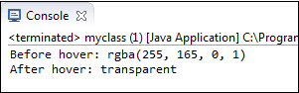](http://cdn.guru99.com/images/image052.png)

**Building a Series of Multiple Actions**

**You can build a series of actions using the Action and Actions classes**. Just remember to close the series with the build() method. Consider the sample code below.

[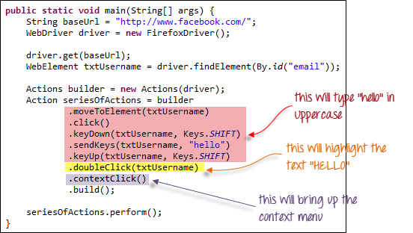](http://cdn.guru99.com/images/image053.png)

[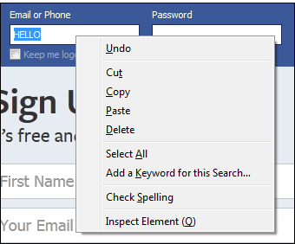](http://cdn.guru99.com/images/image054.png)

**Summary**

* Handling special keyboard and mouse events are done using the AdvancedUserInteractions API.
* Frequently used Keyword and Mouse Events are doubleClick(), keyUp, dragAndDropBy, contextClick & sendKeys